SEO Metadata
- Focus Keyword: best brand design company in Kolkata
- Meta Title: Best Brand Design Company in Kolkata | Off-Page SEO Strategy | Brewing Ideaz
- Meta Description: Discover how Brewing Ideaz can build online visibility as a brand design company in Kolkata through local citations, quality backlinks, guest posting, and brand awareness.
- URL Slug: /off-page-seo-best-brand-design-company-in-kolkata/

Secondary Keywords
- brand design company in Kolkata
- branding agency in Kolkata
- brand identity design Kolkata
- branding services in Kolkata
- creative design agency Kolkata
- logo design company Kolkata
- professional branding company Kolkata
- brand strategy agency Kolkata
- visual identity design Kolkata
- Brewing Ideaz Kolkata

Off-Page SEO Strategy: Best Brand Design Company in Kolkata
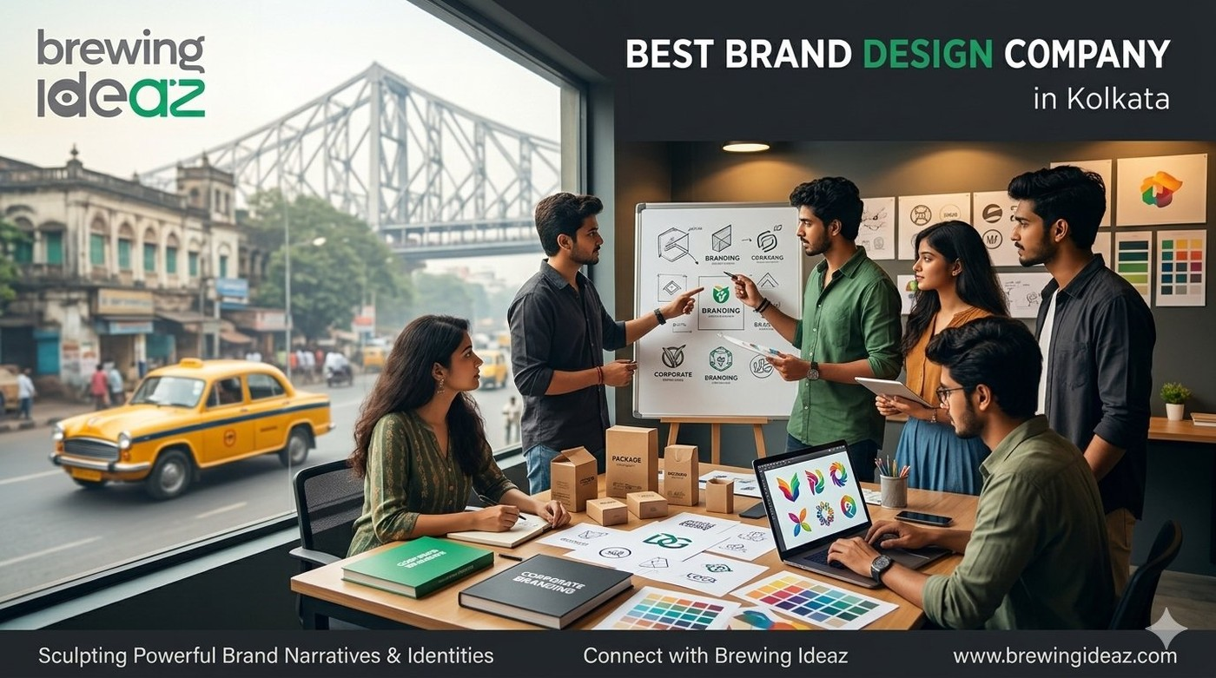
In today’s competitive digital landscape, having a well-designed website is only one part of building a recognizable brand. Businesses also need a strong online presence, credibility, and visibility across relevant platforms.
For companies looking for the best brand design company in Kolkata, off-page SEO can help improve brand discoverability, build meaningful online relationships, and connect with potential clients searching for branding and creative design services.
Brewing Ideaz is a brand design and digital agency with a branch office in Kolkata. A well-planned off-page SEO strategy can help strengthen its online presence and make its services easier to discover.

1. What Is Off-Page SEO?
Off-page SEO refers to activities performed outside a website to improve its online visibility, reputation, and authority.
Unlike on-page SEO, which focuses on website content and structure, off-page SEO focuses on building a brand’s presence across other websites, business directories, social platforms, and relevant online communities.
Key off-page SEO activities include:
- Building relevant backlinks.
- Maintaining local business listings.
- Encouraging genuine customer reviews.
- Publishing guest articles.
- Sharing useful content on social media.
- Building brand mentions and online relationships.

2. Google Business Profile Optimization
Google Business Profile helps eligible businesses manage how their information appears on Google Search and Maps.
Recommended actions include:
- Publish weekly posts featuring the primary keyword or natural variations.
- Upload genuine project photos, team photos, and office images.
- Request honest client reviews mentioning branding or design services.
- Keep the business name, address, and phone number consistent.
- Respond professionally to customer feedback.
- Update business information whenever details change.

3. Local Citations and Business Directories
Brewing Ideaz can review and update relevant listings on:
- Justdial
- Sulekha
- IndiaMART
- Clutch
- Google Business Profile
- Bing Places
- Relevant local Kolkata business directories
Use the exact branch office address and phone number wherever applicable.
Branch Office Address: D-66, Bangur Avenue, Kolkata, West Bengal 700055.

4. Backlink Building and Guest Posting Strategy
Brewing Ideaz can explore guest posting and content collaboration opportunities through:
- YourStory
- Medium
- LinkedIn Articles
- Design, startup, and business blogs with an Indian audience
- Relevant “Best Agencies in Kolkata” and “Best Agencies in East India” listicles

5. Recommended Anchor Text Strategy
- Exact-match keywords: best brand design company in Kolkata
- Close-match keywords: brand design company in Kolkata
- Branded anchors: Brewing Ideaz
- Natural descriptive anchors: our Kolkata brand design team
Suggested distribution: 60% exact-match or close-match anchor text, 40% branded or natural anchor text.

6. Social Media and Community Engagement
- LinkedIn: Share the published blog with insight-led captions.
- X (Twitter): Post key takeaways from the article.
- Reddit: Participate genuinely in relevant communities such as r/Kolkata, r/indianstartups, and r/design.
- Facebook: Share useful content in relevant groups for Kolkata entrepreneurs and marketing professionals.
- LinkedIn Carousel: Create a short carousel summarizing the brand design evaluation checklist.

7. Client Testimonials and Case Studies
- Request honest feedback from completed projects.
- Publish testimonials with client permission.
- Develop case studies describing project objectives and outcomes.
- Share relevant branding projects and creative work.
- Pitch successful projects to relevant local publications.

8. Local Media Outreach and Brand Mentions
- Pitch branding insights to Kolkata business publications.
- Share useful articles with local business newsletters.
- Contribute expert commentary on branding and design topics.
- Monitor online brand mentions and engage thoughtfully.
- Identify relevant local business websites for content collaborations.

9. Tracking and Reporting Off-Page SEO Performance
- Search impressions and clicks in Google Search Console.
- Performance of the primary keyword and its variations.
- Referral traffic from guest posts and local citations.
- Relevant backlinks and brand mentions.
- Google Business Profile insights.
- Local listing accuracy and engagement.

Conclusion
A sustainable off-page SEO strategy combines accurate local business listings, relevant backlinks, useful content, authentic customer feedback, and consistent performance tracking. Brewing Ideaz can strengthen its digital visibility by building meaningful relationships, sharing useful branding insights, and maintaining a consistent presence across relevant online platforms.

Book Your Consultation With Brewing Ideaz
Ready to strengthen your online presence in Kolkata? Get in touch with our team to discuss your goals.
Brewing Ideaz
Phone: (+91) 62915 47048
Email: info@brewingideaz.com
Branch Office: D-66, Bangur Avenue, Kolkata, West Bengal 700055

30 Frequently Asked Questions About Brand Design Company in Kolkata
- What is off-page SEO? Off-page SEO includes activities outside a website that help improve its visibility, reputation, and authority, such as backlinks, brand mentions, reviews, and local citations.
- Why is off-page SEO important for a brand design company in Kolkata? It helps potential clients discover the business through relevant websites, local listings, referrals, and brand mentions.
- What is the best off-page SEO strategy for a brand design company in Kolkata? A balanced strategy includes accurate local listings, relevant backlinks, useful content distribution, genuine customer reviews, and regular performance tracking.
- How does Google Business Profile help local businesses? It helps eligible businesses display accurate information and become discoverable through Google Search and Maps.
- Which directories can a Kolkata business use? Businesses can consider Google Business Profile, Bing Places, Justdial, Sulekha, IndiaMART, Clutch, and relevant local business directories, depending on eligibility.
- What is a backlink? A backlink is a link from another website that directs users to your website.
- How do backlinks help SEO? Relevant, editorially earned backlinks can help search engines discover pages and may contribute to authority and relevance signals.
- What is guest posting? Guest posting involves publishing useful content on another relevant website, often with an appropriate author or business reference.
- Where can a business publish guest articles? Businesses can explore relevant design publications, startup websites, business blogs, and local publications that accept useful contributions.
- What is anchor text? Anchor text is the clickable text in a hyperlink that describes or identifies the linked page.
- What anchor text should a business use? Use natural, descriptive, and branded anchor text rather than repeatedly forcing exact-match keywords into links.
- How important are social media shares for SEO? Social media shares can increase content exposure and attract visits or mentions, but they do not guarantee improved search rankings.
- Which social media platforms can a design company use? LinkedIn, X, Facebook, and relevant online communities may help distribute content and connect with potential clients.
- How can a business get genuine client reviews? Ask clients politely for honest feedback after completing a project and follow the relevant platform’s review policies.
- What is NAP consistency in local SEO? NAP stands for Name, Address, and Phone number. Consistency helps customers and platforms identify the same business across listings.
- Can off-page SEO work without paid advertisements? Yes. Off-page SEO can focus on organic activities such as earning relevant backlinks, maintaining business listings, and sharing useful content.
- How long does off-page SEO take to show results? The timeline varies depending on competition, website history, implementation quality, and other factors. Results are not guaranteed within a specific period.
- What role does content play in off-page SEO? Useful content gives other websites and audiences a reason to reference, share, or discuss the business.
- Should blog images include the company logo? A relevant branded image can support brand recognition. The logo should be clear, and the image should match the article’s topic.
- How can off-page SEO performance be tracked? Google Search Console, analytics reports, business listing insights, and backlink monitoring tools can help track performance.
- Is off-page SEO only about backlinks? No. It can also include local citations, reviews, brand mentions, digital PR, and content outreach.
- Can local SEO be part of off-page SEO? Yes. Local listings, citations, and customer reviews are commonly included in local off-page SEO activities.
- How should a business choose guest-posting websites? Look for topical relevance, a genuine audience, editorial standards, and website credibility. Avoid link schemes.
- What is digital PR in SEO? Digital PR involves earning media coverage and brand mentions by sharing useful stories, research, expert insights, or resources with relevant publishers.
- How can brand awareness support SEO? Brand awareness may lead to more branded searches, website visits, mentions, and links, although results vary.
- Which tools are useful for off-page SEO? Google Search Console, analytics tools, backlink analysis platforms, and Google Business Profile insights can help monitor different aspects of performance.
- Do online reviews directly improve search rankings? Reviews can influence customer trust and local visibility, but rankings depend on multiple factors and are not guaranteed.
- What is a case study in branding? A branding case study explains a project’s goals, process, and outcomes using accurate details and client permission where needed.
- Can a Kolkata business get featured in local publications? Yes. A business can pitch relevant stories, expertise, or project insights to local publications and business communities, though coverage is not guaranteed.
- How can I contact Brewing Ideaz for brand design services in Kolkata? You can contact Brewing Ideaz by calling or WhatsApping +91 62915 47048 or emailing info@brewingideaz.com to discuss your branding requirements.

